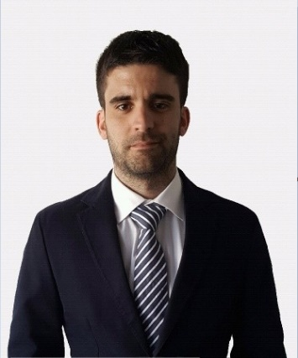
Contact Information
Date of birth: 27/06/1990 (35 años)
Location: A Coruña y Boiro
Phone: 620633616
Email: fran.lopez.olveira@gmail.com
LinkedIn: https://www.linkedin.com/in/francisco-marcial-l%C3%B3pez-olveira/
LÓPEZ OLVEIRA, FRANCISCO MARCIAL
BRIEF INTRODUCTION
Financial professional with experience in financial management, management control, treasury, and business analysis within industrial environments. Results-oriented profile focused on decision-making, financial optimization, and data analysis, holding the CCA certification and currently pursuing the Business Analytics Certificate (BAC).

PROFESSIONAL EXPERIENCE

GALICIA STEEL WIND, S.L. y MONTAJES Y ESTRUCTURAS LAGO, S.L. Mar. 2022 – Apr. 2026 (4 years and 1 month). Chief Financial Officer (CFO).
INCOGA NORTE S.L.U. Aug. 2017 – Mar. 2022 (4 years and 8 months).
- Treasury Manager (Jul. 2020 – Mar. 2022)
- Financial Analyst & Assistant to the Financial Management Department (Aug. 2017 – Jul. 2020)
NORVENTO ENERXÍA, S.A. Apr. 2017 – Aug. 2017 (5 months). Assistant Financial Controller (internship).
INDUSTRIAS DEL TABLERO, S.A. Jul. 2016 – Apr. 2017 (10 months). Commercial Risk Analyst (internship).
BOIRO CITY COUNCIL. Feb. 2016 – Jul. 2016 (6 months). Administrative & Accounting Assistant (internship).
CASTLE ROCK HOSTEL EDINBURGH. Sep. 2014 – Mar. 2015 (7 months). Volunteer through the HelpX platform.
- Objective: improve my English skills and gain an independent international experience.
ROTOGAL S.L. Aug. 2012 – Sep. 2012 (2 months). Administrative & Accounting Assistant. University internship.

EDUACTION

MASTER'S DEGREE IN FINANCIAL MANAGEMENT. IFFE Business School. Oleiros (A Coruña), Oct. 2015 – Jul. 2016. Recognition: Special Mention of the Year.
DEGREE IN ECONOMICS. University of Santiago de Compostela, Sep. 2013 – Feb. 2016.
(*) The degree was actually completed the following year, as I postponed the final dissertation due to my stay abroad in Edinburgh.
BACHELOR’S DEGREE IN BUSINESS ADMINISTRATION AND MANAGEMENT. University of Santiago de Compostela. Finance specialization, Oct. 2008 – Jun. 2013.

ADDITIONAL TRAINING

- Business Analytics Certificate - BAC Certificate®. Chartered Controller Institute, GCCI. In progress, expected Jul. 2026.
- Chartered Controller Analyst - CCA Certificate®. GCCI. Jan. 2026.
- Advanced Management Control Course (Controller). General Council of Economists. Jan. 2026.
- Design and Definition of Compensation Systems: Fixed and Variable. CGADE Management School. Nov. 2024.
- Advanced SAP Course. VIU - International University of Valencia. Jul. 2022.
- Power BI Essential Training. LinkedIn. Jan. 2021.
- Excel: Creating a Business Dashboard with Power Query and Power Pivot. LinkedIn. Jun. 2020.
- Occupational Risk Prevention for Administrative Staff in Construction Companies. Fundación Laboral de la Construcción. Dec. 2018.
- Advanced Excel Course. EF Business School. Oct. 2015.
- Technical Analysis and Risk Management in Financial Markets. Mercalia International Business School. Jun. 2015.
- Psychology in Financial Markets. Mercalia International Business School. May. 2015.
- Mediation Course in Civil, Commercial and Insolvency Matters. European Arbitration Association & College of Economists of Pontevedra. Mar. 2014.

IT SKILLS

Microsoft Excel, Power BI (DAX language), Power Pivot, Power Query, Outlook, Word and PowerPoint.

IDIOMAS

<
Spanish:

<
Galician:

<
English:

Certificates:

- PET (Preliminary English Test). Basil Paterson Cambridge College of Edinburgh.
- Aptis (B2). British Council Bilbao.
- Celga 4 en gallego. Instituto de Educación secundaria Praia de Barraña (Boiro).
English course at Youghal International College, Cork.
International stays: Cork (Ireland), Carcassonne (France), and Edinburgh (Scotland).

OTHER RELEVANT INFORMATION

Driving license (B) and own vehicle.
Recreational Boat Skipper License (PER) for motor and sailing vessels up to 12 meters.

